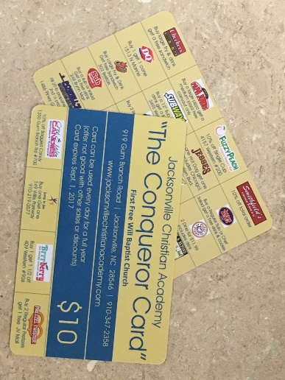




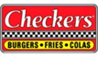


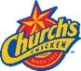




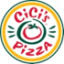






Cindy’s Schepers Photography
Family Dental Care
Lanvermeier & Jarman P.A.
JCA CONQUEROR CARDS
SELL MORE, WIN BIG!!! We are offering great prizes for those who would like to sell more than their required amount of cards. Pick up extra cards at the office.

$1000 CASH $500 CASH STUDENT GIFT BOX

All sales and monies must be turned into the office by Friday, October 18th to be considered for the prizes.

THE WINNERS WILL BE ANNOUNCED
IN A SCHOOL ASSEMBLY ON
FRIDAY, OCTOBER 21st @ 1:00PM.
IF ISSUED TEN (10) CARDS, MONEY IS DUE BY OCTOBER 18TH
IF ISSUED TWENTY CARDS (20) YOU MAY PAY FOR THE FIRST 10 BY OCTOBER 18TH AND THE SECOND 10 BY JANUARY 20TH.
Fundraisers are necessary for the continued improvement of JCA. Our largest fundraiser is the sale of The Conqueror Card. This discount card offers discounts to local businesses. The price of the card is $10 each.
The proceeds assist in our overall general fund which allows the school to keep tuition at a minimal rate for our families.
Each JCA family with one student is responsible for selling ten (10) cards. If you have two or more students you are responsible for selling twenty (20) cards. Conqueror Cards will be billed to your account; credits will be applied as money is turned in.
1st PLACE
2nd PLACE
3rd PLACE

