6th Grade Used Book List

This is your used book list for the sixth grade class. In order for a book to be used for the next
school year it must be in good shape and not have answers written in the book. Please return
this used book list to Miss Kim’s box by Friday, May 27th. Please make sure that if you check
the book off on this list that you will actually have access to that book; otherwise, we start the
school year without everyone having books and having to place more orders.

_____ Mountain Pathways - $17.75

_____ Voyage of Discovery - $17.75

_____ Of America II - $17.75

_____ New World History & Geography - $24.40

_____ Observing God’s World - $22.90

_____ Choosing Good Health - $14.50

Student’s Name: ___________________________________ Total: $__________________

6th Grade Used Books

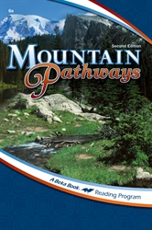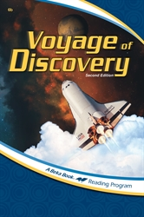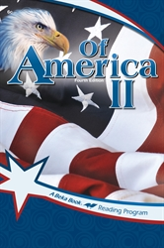

Mountain Pathways Voyage of Discovery Of America II

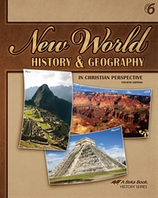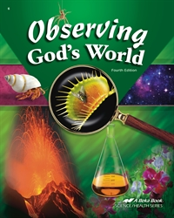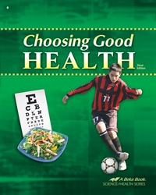

New World History Observing God’s Choosing Good
& Geography World Health

7th Grade Used Book List

This is your used book list for the seventh grade class. In order for a book to be used for the next
school year it must be in good shape and not have answers written in the book. Please return
this used book list to Miss Kim’s box by Friday, May 27th. Please make sure that if you check
the book off on this list that you will actually have access to that book; otherwise, we start the
school year without everyone having books and having to place more orders.

_____ Literature: Of People - $29.80

_____ History of the World - $28.60

_____ Science: Order & Design - $31.90

Student’s Name: ___________________________________ Total: $__________________

7th Grade Used Books

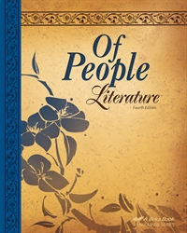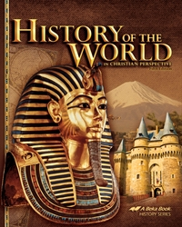

Literature: Of People History of the World

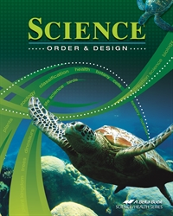

Science: Order & Design

8th Grade Used Book List

This is your used book list for the eight grade class. In order for a book to be used for the next
school year it must be in good shape and not have answers written in the book. Please return
this used book list to Miss Kim’s box by Friday, May 27th. Please make sure that if you check
the book off on this list that you will actually have access to that book; otherwise, we start the
school year without everyone having books and having to place more orders.

_____ Literature: Of Places - $29.80

_____ America: Land I Love - $28.60

_____ Science: Earth & Space - $31.90

Student’s Name: ___________________________________ Total: $__________________

8th Grade Used Books

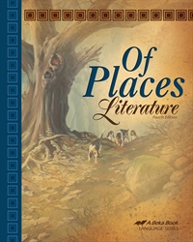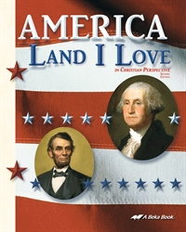

Literature: Of Places America: Land I Love

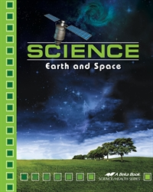

Science: Earth and Space

9th Grade Used Book List

This is your used book list for the freshman class. In order for a book to be used for the next
school year it must be in good shape and not have answers written in the book. Please return
this used book list to Miss Kim’s box by Friday, May 27th. Please make sure that if you check
the book off on this list that you will actually have access to that book; otherwise, we start the
school year without everyone having books and having to place more orders.

_____ Themes in Literature - $29.80

_____ World Geography in Christian Perspective - $25.30

_____ Health in Christian Perspective - $25.30

_____ Spanish I: Por Todo el Mundo Vocabulary - $22.00

_____ Spanish I: Por Todo el Mundo Books A/B - $46.25

Student’s Name: ___________________________________ Total: $__________________

9th Grade Used Books

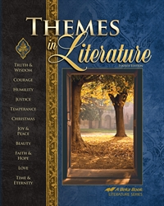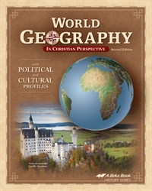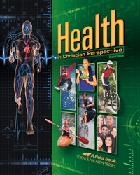
Themes in Literature World Geography in Health in Christian Perspective Christian Perspective

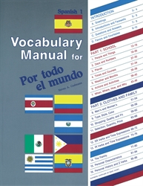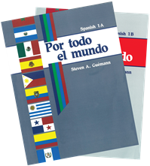
Spanish I: Por Todo el Mundo Spanish I: Por Todo el Mundo Vocabulary Books A/B

10th Grade Used Book List

This is your used book list for the sophomore class. In order for a book to be used for the next
school year it must be in good shape and not have answers written in the book. Please return
this used book list to Miss Kim’s box by Friday, May 27th. Please make sure that if you check
the book off on this list that you will actually have access to that book; otherwise, we start the
school year without everyone having books and having to place more orders.

_____ World Literature - $33.05

_____ Julius Caesar - $12.95

_____ U. S. History: Heritage of Freedom - $31.90

_____ Science: Matter & Energy - $34.35

_____ Spanish I: Por Todo el Mundo Vocabulary - $22.00

_____ Spanish I: Por Todo el Mundo Books A/B - $46.25

Student’s Name: ___________________________________ Total: $__________________

10th Grade Used Books

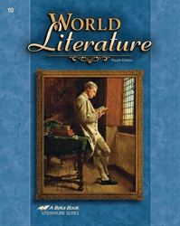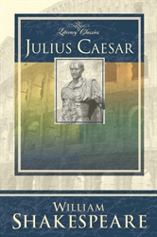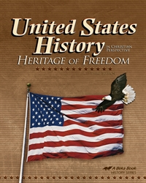
World Literature Julius Caesar United States History:
Heritage of Freedom

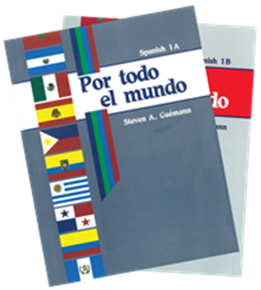
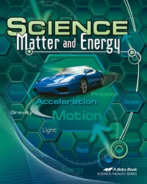
Science: Matter & Energy Spanish I: Spanish I:
Por Todo el Mundo Vocabulary Por Todo el Mundo 1A/1B

11th Grade Used Book List

This is your used book list for the junior class. In order for a book to be used for the next
school year it must be in good shape and not have answers written in the book. Please return
this used book list to Miss Kim’s box by Friday, May 27th. Please make sure that if you check
the book off on this list that you will actually have access to that book; otherwise, we start the
school year without everyone having books and having to place more orders.

_____ Handbook of Grammar & Composition - $20.75

_____ American Literature - $37.00

_____ World History and Cultures - $31.90

_____ Life Management Under God - $17.75

_____ Chemistry: Precision & Design - $48.10

Student’s Name: ___________________________________ Total: $__________________

11th Grade Used Books

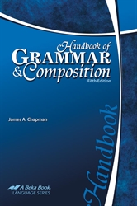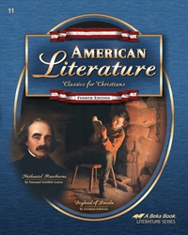
Handbook of American Literature
Grammar & Composition

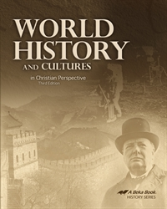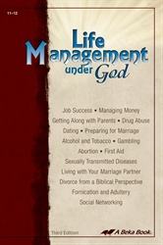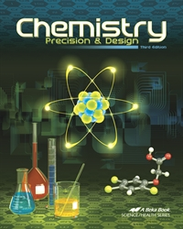
World History and Life Management Chemistry: Precision & Design Cultures Under God

12th Grade Used Book List

This is your used book list for the senior class. In order for a book to be used for the next
school year it must be in good shape and not have answers written in the book. Please return
this used book list to Miss Kim’s box by Friday, May 27th. Please make sure that if you check
the book off on this list that you will actually have access to that book; otherwise, we start the
school year without everyone having books and having to place more orders.

_____ Handbook of Grammar & Composition - $20.75

_____ English Literature - $37.00

_____ Macbeth - $12.95

_____ American Government - $25.30

_____ Economics: Work & Prosperity - $26.80

_____ Chemistry: Precision & Design - $48.10

Student’s Name: ___________________________________ Total: $__________________

12th Grade Used Books

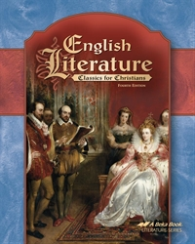 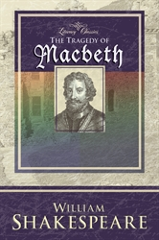 Handbook of English Literature Macbeth Grammer & Compostition

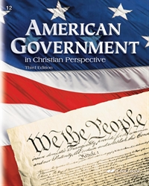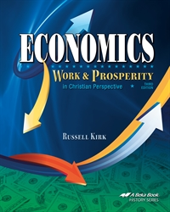
American Government Economics: Work & Prosperity Chemistry: Precision & Design

