FREE ADMISSION

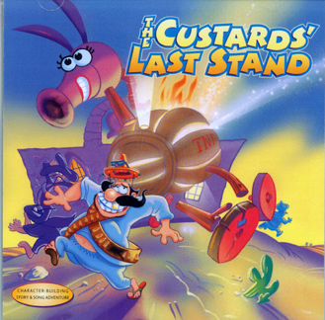
Our JCA drama team will present:

Featuring our 2nd – 5th grade choir.

WHEN: FRIDAY, MAY 20, 2016
WHERE: JCA AUDITORIUM 919 Gum Branch Road
TIME: 7:00PM

FREE ADMISSION

